

**Telephone User Guide**

# NEC SV9100

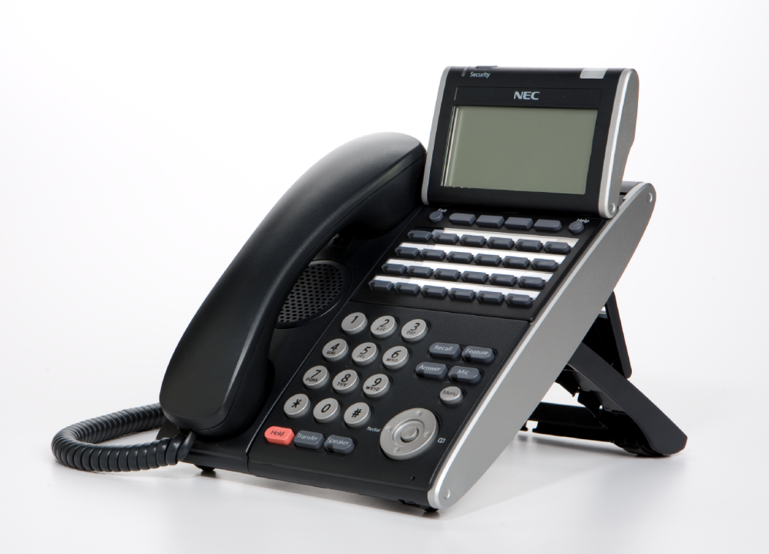

Phone: 714.855.4577

www.tritoncomm.com

# Quick Reference Guide

**NEC SV9100**

# Function Function Description

**GREEN LED** Your Call

**RED LED**  Somewhere else in building (on another handset)

**SOLID RED OR GREEN** Station with call in progress or with a call on exclusive hold

**SLOW FLASHING LED** A call that has been placed on hold

**FAST FLASHING LED** An incoming call

**ANSWER A CALL Handsets which have line keys:**

If your handset **rings** on incoming calls, **lift handset**

**OR**

If your handset does not ring, **Lift Handset** and **press the line** key

**OR**

While on a call, ask caller to hold, then press “**ANSWER**” key (Only on ring assigned handsets)

**Handsets which have CAP and Park keys:**

If your handset rings on incoming calls, **lift handset** (call will appear on **CAP** key) **OR**

If your handset does not ring, **Lift Handset** and press **P/U soft key x 2**

**INTERNAL CALL PICKUP When you know the extension that is ringing and want to pick up that call:**

* **Lift Handset**
* Dial* * **Extn No.**

**HANDSET RECEIVER**

**SPEAKER VOLUME**  **USING THE UP/DOWN KEY**

* **Handset Receiver** **volume** press up/down key in off hook status or during

call

**HANDSET** ◾◾◾◾- - - - - - - - - - -

* **Ring volume** press up/down key when station is ringing.

**RING** ◾◾◾◾◾◾◾◾◾◾- - - - - - - - -

* **Speaker volume** press up/down key during speakerphone operation or

during the call

**SPEAKER** ◾◾◾◾◾◾◾◾◾◾- - - - - - - - -

* **LCD Screen Contrast** press up/down key in the on-hook status

**LCD**◾◾◾◾◾◾- - - - - - - - -

**MIC / MICROPHONE** **To Turn your microphone On/Off for hands free only:**

**LED** on **Mic** key shows the status of the built-in microphone

Press **MIC** button

(Red light indicates MIC is on)

**HANDSFREE To make a hands free call,**

* Press **Speaker** key,
* Dial **Extension number** **OR** Dial **“0”** for an outside line THEN phone number

**MAKE A CALL** **Internal Calls**

* **Lift Handset or Press Speaker**
* **Dial Extension number**

**External Calls**

**Lift handset** or press **Speaker**

* Press “**0”**  then dial phone number

**OR**

* Press **Redial** then **3 digit code speed dial code**

**HOLD To place a call on hold:**

* Press **Hold** button once.

To place a call on exclusive hold **(no-one else can pick up your call)**

* Press **Feature**
* Press **Hold**

**To place a call on hold using Park keys:**

* Press the first available **Park** button once.

**TRANSFERING CALLS To Transfer a call to another extension:**

* Press **Hold** to put the call on hold
* Dial **Extension Number or press One Touch Key,**
* **Announce call**
* Press **Transfer OR Advise of line number**
* **Hang up.** Call is transferred.

**To transfer calls from a cordless phone (**Panasonic**):**

* **While speaking on an outside line:**
* Press **Recall button** (which puts the call on hold),
* Dial  **Extension number,**
* **Announce the call and hang up.**

**Transferring to**

**Voicemail To transfer a call to a person’s voice mail:**

* **While speaking to the outside line,**
* Press **Hold**
* Dial **Person’s extension number**
* Press “**8**”
* Press **Transfer**
* **Hang Up**

**TRANSFER OFFSITE Transfer an incoming line to another outside line**

**While talking to the incoming call**

* Press **Hold** key
* **Select an outside line**
* Dial **Phone number**
* **Announce you will be transferring call**
* Press **Transfer** key
* **Hang Up**



**REDIAL To dial the last number phoned:**

* Press **Redial key** without lifting handset
* Press # To redial last number

**OR**

* Press **List Soft key** to search for desired number
* Then **Redial Soft key**
* Press Up/Down Key to search number
* Then Lift handset or press **Speaker** to place the call

**CORDLESS PHONE** To **make calls** –

* Press **Talk/on** or green phone key,
* dial **0,** then
* dial **Phone number**

**To answer calls,**

* press **talk/on** or green phone key symbol when ringing

**To Transfer calls –**

* Press **Recall/Flash** to Hold.
* Dial **Extension number**, announce,

#### INTERNAL PAGING To make an internal page through all desktop handsets:

* Press **ICM** menu option for intercom
* Press **Inpg** menu option for Internal Page
* Press “0” which is group no 1 for all internal page
* Lift **Handset and make announcement**
* Hang up

**OR Manually:**

* Lift **Handset**
* Dial **701**
* Press“**0**” (for all Zones)
* Make **Announcement** and replace handset

*(Note: This feature is announcement only-extensions cannot reply)*

**EXTERNAL PAGING To make an external page through a Paging Horn:**

* Lift **Handset**
* Dial **703**
* Press “**0**” (for all Zones)
* Make **Announcement** and replace handset

(Note: This feature only works if an external speaker is installed)

**COMBINED PAGING** **To page both internal & external zones:**

* Lift **Handset**
* Dial **\*1**
* Make **Announcement** and replace handset

**CONFERENCE** **CALLS To set up a Conference Call:**

While on an **Outside** call or connected to your first party

* Press **Conf** Key on Display
* Dialan **outside** line or second party

(When called party answers)

* Press **Add key** on screen

(Repeat steps 2-4 to add more parties. Maximum of 16 internal or external parties can be conferenced).

* Press **Begin** to start conference

**To exit a Conference without affecting the other parties:**

* **Hang up**

🠋🕻

**MISSED CALLS To view numbers of calls missed on your handset**

**Your handset will display this symbol**



* Press **Centre** button on the Jog Dial
* Press **Centre** button on Jog Dial to select ➀ Missed Calls ●
* Scroll **🡫** Down soft key to desired number
* Lift **Handset** to call – Handset will dial automatically

**OR**

* Press **DEL** soft key to delete
* Press **Store** soft key to save

**SET INTERCOM TO EITHER**

**RINGING OR HANDSFREE To select your intercom to be hands free:**

* Press **Speaker**
* Dial  **721**
* Press **Speaker** to hang up

**To select your intercom to be ringing:**

* Press **Speaker**
* Dial **723**
* Press **Speaker** to hang up

**SELECTABLE RING TONES To CHANGE your Extension’s incoming ring tones:**

* Press **Speaker key**
* Dial **720**
* Dial **1** to set **intercom** ring, or **2** to set **external** **call** ring
* Dial **Code** for the ring pattern you wish to hear:

**1** = High **5** = Ring Tone 2

**2** = Mid Range **6** = Ring Tone 3

**3** = Low **7** = Ring Tone 4

**4** = Ring Tone 1 **8** = Ring Tone 5

* Press **Speaker** to Hang Up

**To Listen to the Incoming ring choices**

* Press Speaker and Dial 711
* Dial 1 to listen to **intercom** ring
* Dial 2 to listen to **external call** ring

**Then for INTERCOM**

* Dial 1-8 Code for ring pattern

**Or for EXTERNAL CALL**

* Dial 1-3 (ring) 4-8 (melody)
* Press Speaker to Hang up

#### STATION NAME ASSIGNMENT To assign a name to your extension number:

* Press **Speaker**
* Dial **700**
* Press **Hold**
* Enter your **Name** - up to 12 digits(## for space. # between digits on same key)
* Press **Hold**
* Press **Speaker** to hang up

**To program any extension’s name:**

* Press **Speaker**
* Dial **700**
* Enter **Extension Number** to be named
* Enter the **Name** – up to 12 digits
* Press **Hold**
* Press **Speaker** to hang up

**CALL FORWARD ALL**

**CALLS TO ANOTHER**

**EXTENSION OR OFF-SITE To set via menu on the screen:**

* Press **PRG** Soft Key
* Press **C/Fwd** Key
* Press **All** Key
* Press **Set** Key
* Dial The **Extension Number**

**OR**

* Dial “**0**” for an **off-site number**, then **dial the number**

(eg: 0, 0418710111)

* Press **Speaker** key to hang up

**To set on a handset without a display screen:**

* Press **Speaker**
* Dial **Call Forward Code** - **741** for **immediate**

- **744** for **busy/no answer**

* Dial **1** to set
* Dial **extension number**
* Press **Speaker**

**To deactivate:**

* Press **PRG**
* Press **C/fwd**
* Press **All**
* Press **Cancel**
* Press **Speaker**

**Hang up**

**CALL FORWARD YOUR**

**HANDSET TO VOICEMAIL**

**IF BUSY/NOT ANSWERING**

**To set via menu on the screen:**

* Press **PRG** Soft Key
* Press **C/fwd** Soft key
* Press **Arrow** end option on menu
* Press **B/NA** for Busy/No Answer
* Press **Set**
* Dial “**200**” for voicemail
* Press **Speaker** key to hang up

**To Cancel**

* Press **PRG** Soft Key
* Press **C/fwd**
* Press **Arrow** end option on menu
* Press **B/NA**
* Press **Cancel**
* Press **Speaker** to hang up

**DO NOT DISTURB**  **To Activate via Menu on the screen:**

* Press **PRG** Soft Key
* Press **DND** Soft Key
* Press **Set** Soft Key
* Press **All** Soft Key

**To Deactivate via Menu on the screen:**

* Press **PRG** Soft Key
* Press **DND** Soft Key
* Press **Cncl** Soft Key for Cancel

**To Activate On and Off on a handset without display: (Leave Handset Down)**

* Press **Speaker**
* Dial **747**
* Dial **DND** Option Code 1 = Block incoming calls

2 = Block internal intercom

**3 = Block All calls**

4 = Block Call Forwards Only

0 = Cancel DND

**BACKGROUND MUSIC** Can be played through telephone speaker

**To set and cancel**

* Press **Speaker**
* Press **725**
* Press **Speaker**

**ALARM CLOCK** **To activate an alarm:**

* Press **Speaker**
* Dial **727**
* Dial **Alarm Type** 1 – Sounds Only Once

2 – Sounds each day at preset time

* Dial **Alarm time** (24 hour clock) (A confirmation tone will be heard)
* Press **Speaker** to hang up

**To silence an alarm:**

* Press **Exit**

**To check a programmed alarm time:**

* Press **Help** button
* Dial **727**
* Dial **alarm** type 1 or 2

The programmed time displays

* Press **EXIT**

**To cancel an alarm:**

* Press **Speaker**
* Dial **727**
* Dial **alarm** type **1** or **2**
* Dial **9999**
* Press **Speaker** to hang up

**CHANGING THE TIME Note – Must be done from reception or main handset**

**Leave Handset Down**

* Press **Speaker**
* Dial **728**
* Dial two digits for the **hour** (24 hour)
* Dial two digits for the **minutes**
* Press **Speaker** to hang up

***NOTE:*** *The date can only be set / changed in system programming*

**BARGE IN (INTERRUPT A CALL)*\** *Note - Must be activated in programming***

* Lift **Handset**
* Dial **710**
* Dial **Busy Extension** (The extension user will hear a **warning tone).**

**ROOM MONITOR Room monitor lets an extension listen to the sounds in co-workers area, for**

**example, a receptionist could listen for sounds in the warehouse when it’s**

**left unattended.**

***NOTE:*** *(A Room monitor key must be programmed. Room monitor must be*

*activated at the extension initiating the monitor and at the extension that is to be*

*monitored. You can only listen to one extension at a time.)*

**To activate Room Monitor from initiating extension:**

* Press **Room Monitor key**
* Dial **Extension number** you are at

*(You can place and answer calls whilst monitor is active)*

**To activate Room Monitor from extension to be monitored:**

* Press **Room Monitor** key
* Dial **Extension number** you are at

**DIRECTORY DIALLING Displays a list of Speed Dials, Extensions, Personal Speed Dials, and the Telephone Book to select from:**



**To Access The Telephone Book directly:**

* Press 🕮 on the **Jog Dial 🕮**

**OR**

**For all other lists:**

* Press **Dir** soft key (for directory)
* Press **Soft key** (according to list)

**SPD** – Speed Dials

**EXT** – co-worker’s Extensions

**STA** – Personal Speed Dials

**TELBK** – Telephone Book

**THEN**

* Dial The **first letter** of the name you are looking for
* Press 🡫 Soft Key to jump to that section
* Press **Arrow** up or down to scroll through the list
* Lift  **Handset** or press **Dial** Soft Key or press **Speaker** to place call

**To cancel Directory Dialling:**

* Press **Exit** key

**SYSTEM SPEED DIALLING**

**To Store Abbreviated Dialling number:**

* Press **Speaker** key.
* Dial **753**
* Dial **Speed Dial Code** - System **001 to 999**
* Dial **Telephone Number** you want to store (no leading 0 required).
* Press **HOLD.**
* Enter **Name** of the company or person using the keypad.

(## for space, # to move cursor if two digits on same key)

* Press **HOLD**.
* Press **Speaker** to hang up.

**To Dial Abbreviated number:**

* Press **DIR** soft key menu button,
* Press **SYS** soft button,
* Enter **First letter** of their name,
* Press **Arrow keys** to scroll,
* Lift **Handset** to dial

**OR**

**If you know the code you wish to dial:**

* Press **Redial**
* Dial **Code (eg:001-899**),
* Lift  **Handset** or Press Speaker

**Access Speed Dials from Cordless**

* Press **Talk/On Button**
* Press #2
* Dial **Speed dial** code

**Check Abbreviated Dialling numbers:**

* Press **Help**
* Press **Redial key**
* Dial **Abbreviated Dialling Code** and check number
* Press **Exit** when finished

**PROGRAMMING ONE TOUCH BUTTONS**

**Program One Touch Buttons for External Phone Numbers:**

* Press **SPK**
* Dial **751**
* Press **KEY** you wish to program
* Enter **01**
* Enter **0** for an outside line
* Enter **Phone number**
* Press **HOLD**
* Press **SPK**

**Program Function Buttons for Internal Extensions:**

* Press **SPK**
* Dial **751**
* Press **KEY** you wish to program
* Enter **01**
* Enter **Extension Number**
* Press **HOLD**
* Press **SPK**

**Program Function Buttons for all other features:**

* Press **SPK key**
* Dial **751.**
* Press **Key** you want to program.
* Enter **2-digit key function** (see next page)
* Press **HOLD**
* Press **SPK**

**Program Function Buttons for extension names:**

* Press **SPK key**
* Dial **751.**
* Press **key** you want to program.
* Enter **55**
* Press **Hold**
* Press **SPK**

**Program extension names:**

* Press **Ext Names Button**
* Enter **Extension Number**
* Type **The extension Name** (remember # for space, Conf for backspace)
* Press **Hold**
* Press **SPK**

**Available 2-digit key function** **functions are:**

* **00** Not Defined
  + - **01** DSS/One-Touch Key
    - **03** DND Key
    - **04** BGM (ON/OFF)
    - **05** Headset Key
    - **08** Incoming Caller-ID List
    - **09** Day / Night Switch
    - **10** Call Forward-Immediate
    - **11** Call Forward-Busy
    - **12** Call Forward-No Answer
    - **13** Call Forward-Busy/No Answer
    - **14** Call Forward-Dual Ring
    - **15** Call Forward-Follow Me
    - **16** –Not Used-
    - **17** –Not Used-
    - **18** Text message set up.
    - **19** External Group Paging
    - **20** External All Call Paging
    - **21** Internal Group Paging
* **22** Internal All Call Paging
* **23** Meet-Me Answer to Internal Paging
* **24** Call Pickup for Own Group
* **25** Call Pickup for Another Group
* **26** Call Pickup for Specified Group
* **27** Abbreviated Dial-Common/Personal
* **28** Abbreviated Dial-Group
* **29** Repeat Dial
* **30** Saved Number Redial
* **31** Memo Dial
* **32** Meet-Me Conference
* **35** Call Back Request (camp on)
* **37** DND/FWD Override
* **38** Message Wait Button
* **55** Extension Name Edit
* **63** Restrict Caller-ID (ISDN)
* **45** Exclusive Hold
* **48** Voice Over
* **49** to Redirect
* **50** Account Code
* **66** CTI Comms
* **77** Voice Mail(In Skin)
* **78 Conversation Record**
* **79** Automated Attendant
* **SC 852:**
* **\*00** Not used
* **\*01** Trunk Key
* **\*02** Trunk Group/ Loop Key
* **\*03** Virtual Extension Key
* **\*04** Park Hold Key
* **\*05** Loop key

**TO SET YOUR PHONE TO DISPLAY A MESSAGE ON THE SCREEN WHEN SOMEONE DIALS YOUR EXTENSION (FOR WHEN YOU ARE OUT OF THE OFFICE):**

**Set up a Text Message Key first – Spkr 751, press spare button, dial 1801, press hold, press speaker**

**Then to set:**

* Press **Speaker Button**,
* Press **Text Message Key** (programmed above)

**Use the up/down keys to scroll through options**

**Select Option Code Below**

**Change** **time as appropriate, press speaker to set**



**01 In meeting until ___:___**

**Enter Time**,

* Press **Speaker** button to set.

**02 In meeting room**

* Enter **Time**,
* Press **Speaker** button to set.

**03 Come back**

* Enter **Time** coming back,
* Press **Speaker** button to set.

**04 Please call …….**

* Enter **Phone number**,
* Press **Speaker** button to set.

**05 Busy call after**

* Enter **Time,**
* Press **Speaker** to set.

**06 Out for lunch back at ……/…...**

* Enter **Time**,
* Press **Speaker** button to set.

**07 Business Trip back at ……/…….**

* Enter **Date,**
* Press **Speaker** button to set.

**08 Business Trip…….one day trip**

* Enter **Date,**
* press **Speaker** button to set

**09 Gone for the day.**

* Press **Speaker** button to set.

**10 On Vacation until ……./…….**

* Enter **Date,**
* Press **Speaker** button to set

**To cancel**

* Press: **Speaker**
* Press **Test Message Key**
* Press **Speaker** to hang up

**\* Techs can program custom messages if required, e.g. codes 11-20**

**SOFT KEY MENU (MENU’S ON DISPLAY SCREEN)**

|  |  |  |
| --- | --- | --- |
| No. | Menu Item | Description |
| 1 | Call History | To view Call History. For details, see  Call History operation section. |
| 2 | Directory | To use Directory function. For details see Directory operation section |
| 3 | Tool | Uses when accessing external XML  Server. For details, please contact the system administrator. |
| 4 | Call Function | Currently Not Used (greyed out) |
| 5 | Setting | To set up the terminal such as ringing volume control, LCD display setting and download of Music on Hold. |
| 6 | Presence | Currently Not Used (greyed out) |
| # | Favorite | By registering frequently-used features as favourite, the user can access these features with simple operation. |
| 0 | Terminal Config | This item is used for Configuration setting of DT Series. |

**History Menu**

|  |  |  |  |
| --- | --- | --- | --- |
| LIST MENU | Key | Name | Description |
|  | 1 | REDIAL | Detailed info. of last call |
|  | 2 | CID | Former records |

**Directory Menu**

|  |  |  |
| --- | --- | --- |
| Key | Name | Description |
| 1 | REGIST | To add new data |
| 2 | SEARCH | To find registered data |
| 3 | SETTING |  |
| 4 | Delete All | Delete all history |